**Capstone Project**

Barou Anna

11/9/2018

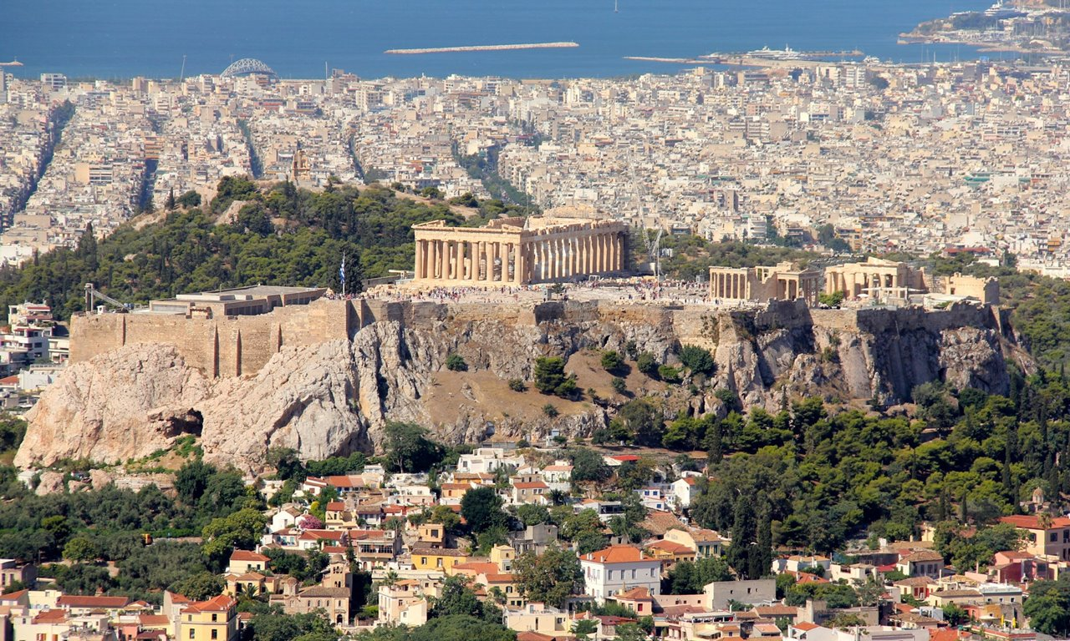

**“The Battle of Athens’s Neighborhoods, Greece”**

**Table of Contents**

Introduction/Business Problem 2

Data section 3

methodology section 7

Results section 14

discussion section 17

conclusion section 18

# **Introduction/Business Problem**

**A Friend of mine which is Pharmacist is looking to set up new “Pharmacy” store in a neighborhood of Athens, Greece.**

**He needs his pharmacy’s location to be near his home location, so specific municipalities of Athens (24 different municipalities of Athens) are investigated.**

**To be sure that his new pharmacy store will have good profit, he requires to:**

* **set up his business to a municipality that live lot of people (so, we examine each municipality population)**
* **to be as near as possible to a Hospital**
* **to be as far as possible to other competitors’ Pharmacy stores**

**This report is focused to propose the better location for my friend Pharmacist to set up a new “Pharmacy” store, according to above requirements.**

# **Data section**

**Below data are used to examine this case:**

**First of all, I need a list of Athens (Attica, Greece) Municipalities with their population figure. According to “**General Secretariat of National Statistical Service of Greece**” there is a table that shows population (latest figures from year 2011) per Municipality. So, I use below page to extract required information:**

<http://www.citypopulation.de/php/greece-attiki.php>

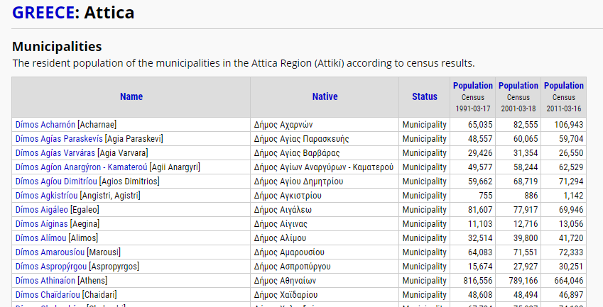

**As we can see, this table has 6 columns:**

* **first column “Name”, list all names of Athens (Attica) Municipalities**
* **second column “Native” has its municipality name in Greek**
* **third column “Status” states that each name corresponds to Municipality**
* **fourth column shows each municipality Population figure from year 1991**
* **fifth column shows each municipality Population figure from year 2001**
* **sixth column shows each municipality Population figure from year 2011**

**From above table, first and last column have the information we need.**

**Then, to continue my investigation I ask my friend Pharmacist to provide me with name of municipalities that is interested to set up his business. He is only interesting to specific 26 municipalities: Agia Paraskevi, Agios Dimitrios, Alimos, Marousi, Chalandri, Dafni-Ymittos, Elliniko-Argyroupoli, Filothei-Psychiko, Galatsi, Glyfada, Ilioupoli, Irakleio, Kessariani, Kallithea, Kifisia, Lykovrysi-Pefki, Metamorfosi, Nea Ionia, Nea Smyrni, Palaio Faliro, Papagou-Cholargos, Penteliri-Voula-Vouliagmeni, Vrilissia, Vyronas, Zografos.**

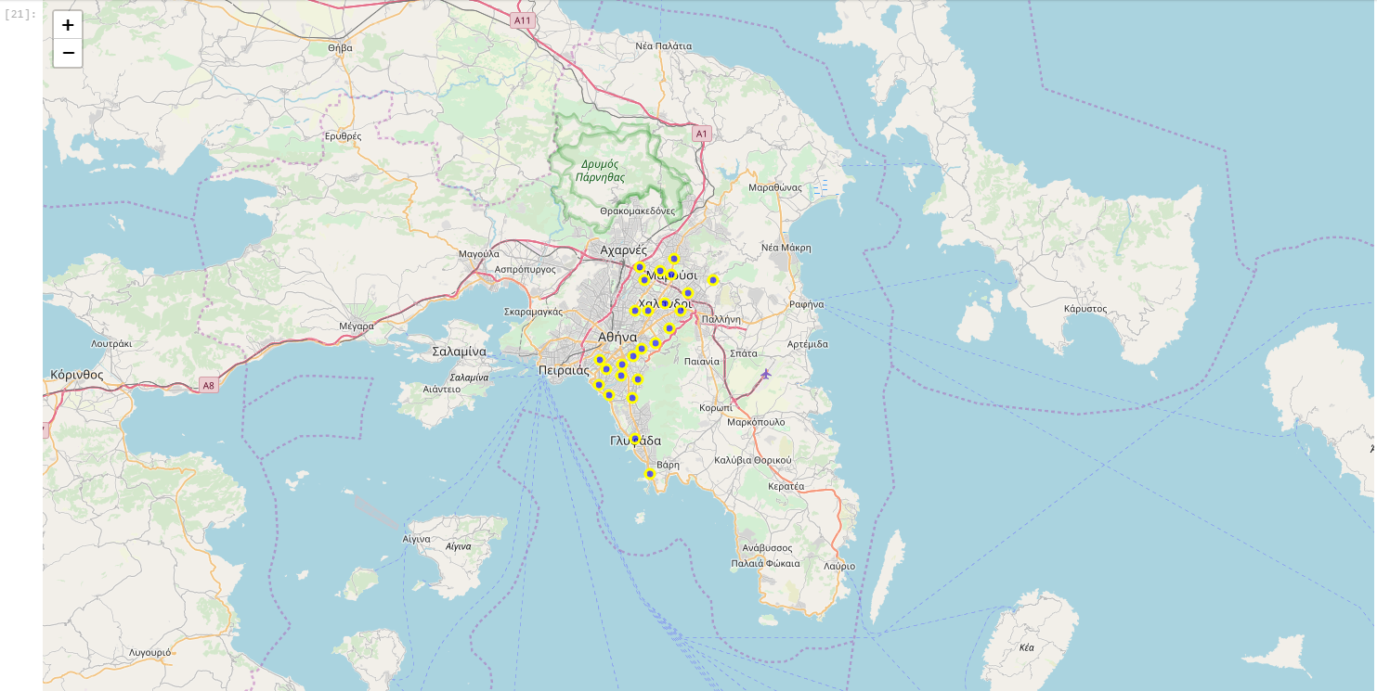

**Then, I prepared a csv file that lists all above municipalities and their coordination: (**<https://github.com/abarou12/Coursera_Capstone/blob/master/coordinates.csv> **)**

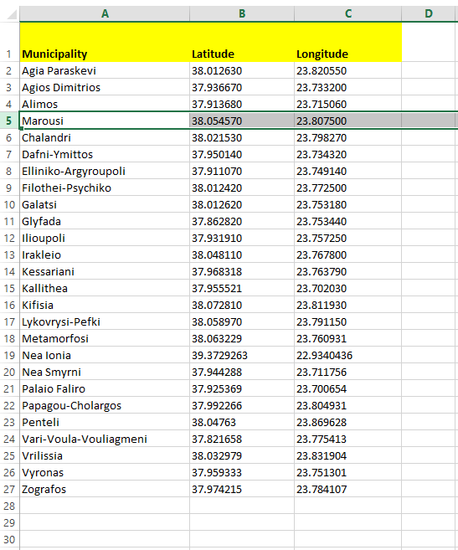

**To continue, I use Foursquare.com (**<https://foursquare.com/>**) to fetch**

* **all other competitor’s Pharmacy with their coordinates and distance from center of each Municipality**
* **all Hospitals for each interested Municipality.**

**Using Folium (**<https://pypi.org/project/folium/> **), I create relative maps to view interested results: e.g. for municipality named “Marousi”, a map is created that shows competitors’ Pharmacy (red cycles) and Medical Centers/Hospitals (blue cycles)**

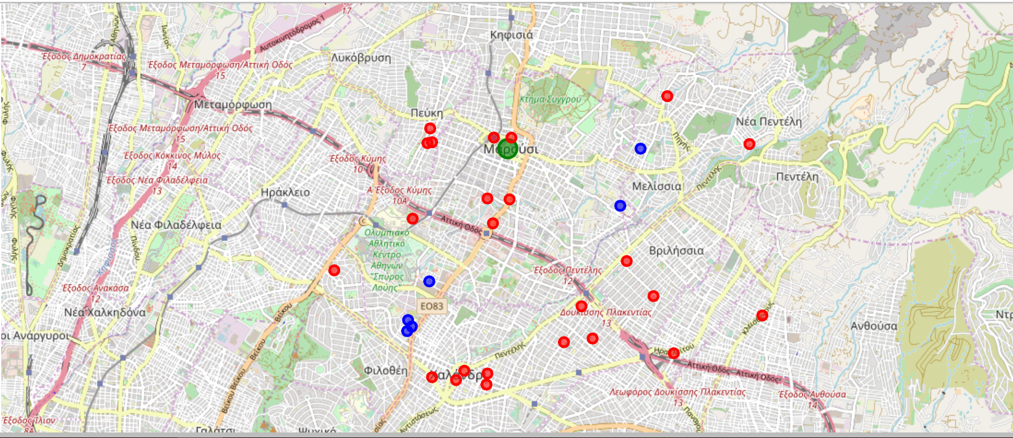

With above data, I will examine and compare all 26 municipalities and using K-means algorithm, I propose the best location for new “Pharmacy” to be set up.

# **methodology section**

First, from internet page “City Population” I extract -using Beautiful soup - only Municipalities table data, and create a List with table’s data.

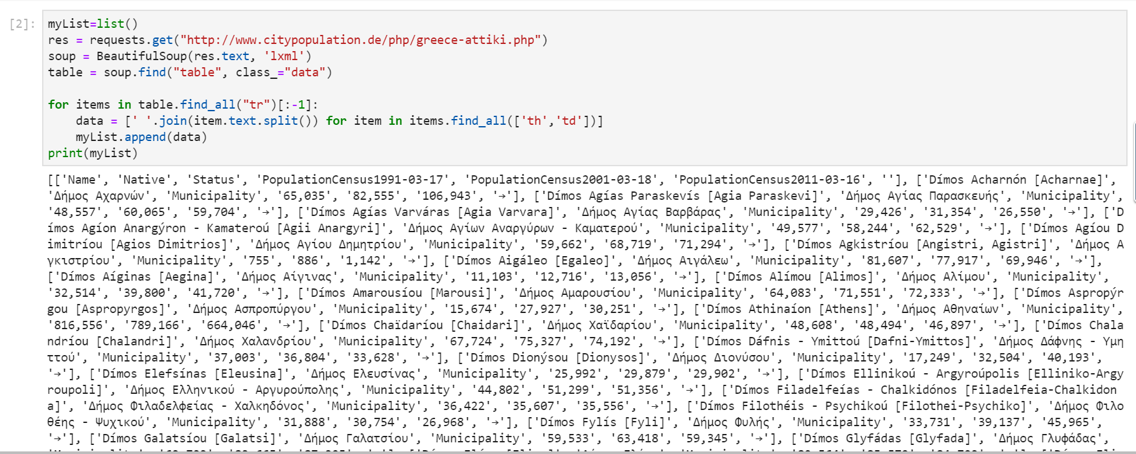

Then I transform above List to Dataframe, rename columns and reset index:

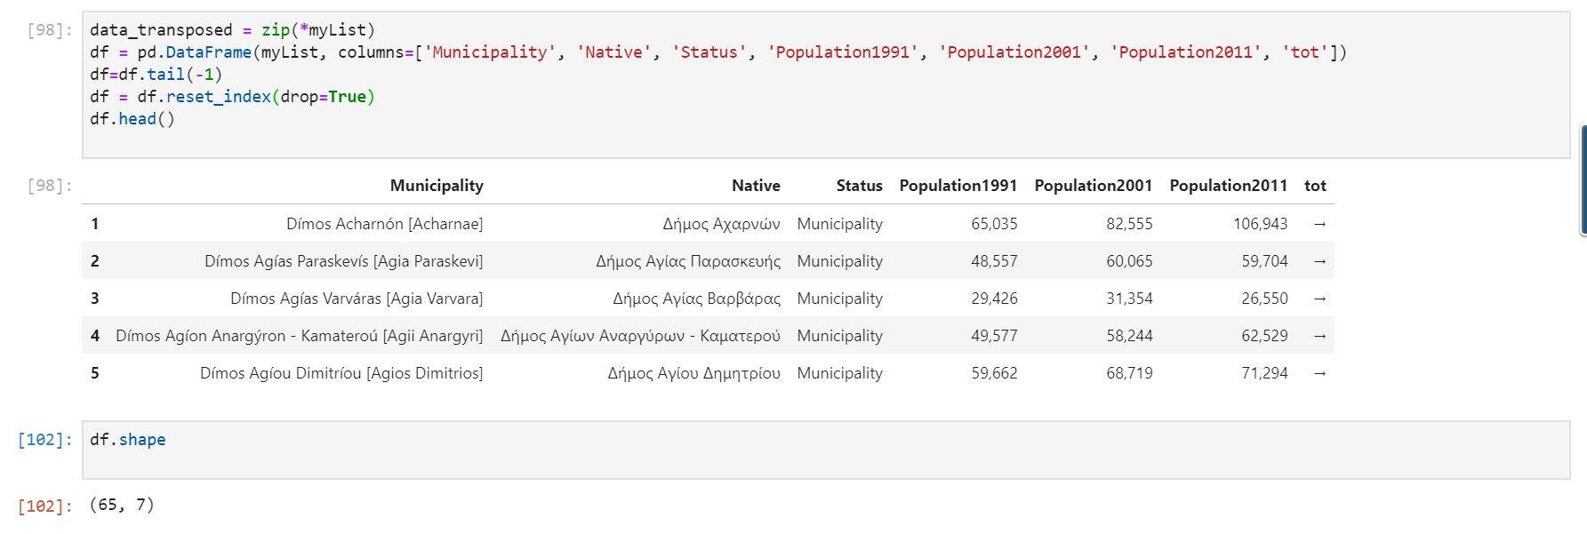

**From dataframe shape, we can see that there are 65 different Municipalities in Athens, Attica area.**

**Then I drop some columns that are not needed, and I keep Municipalities name, the one that is inside brackets:**

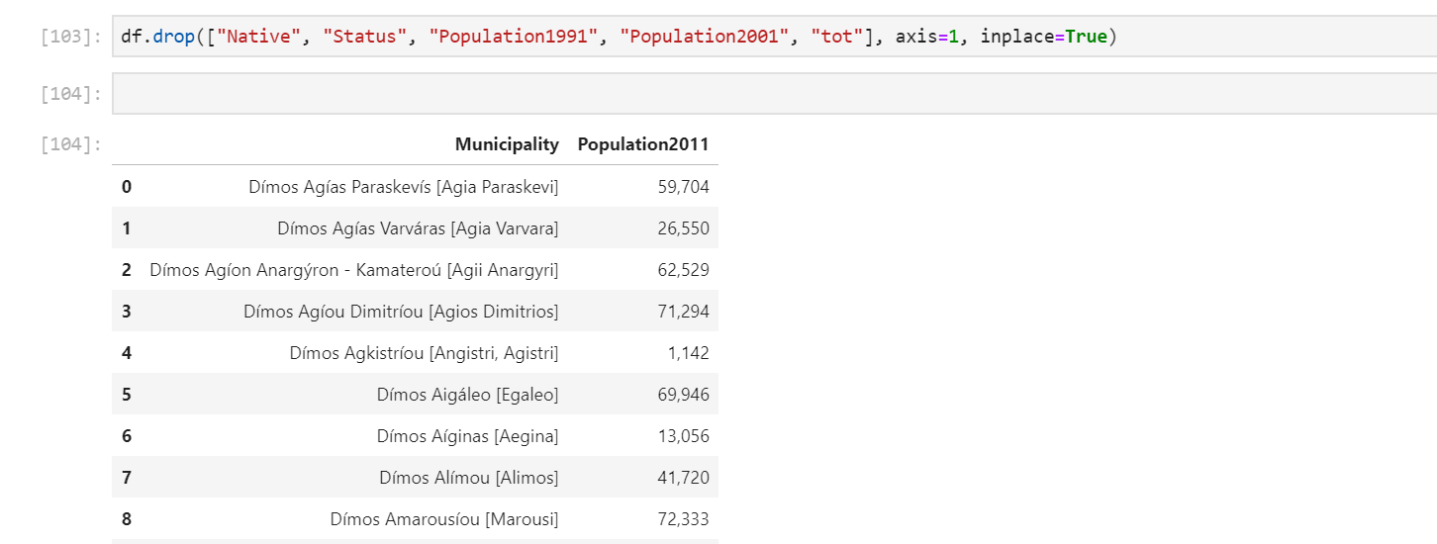

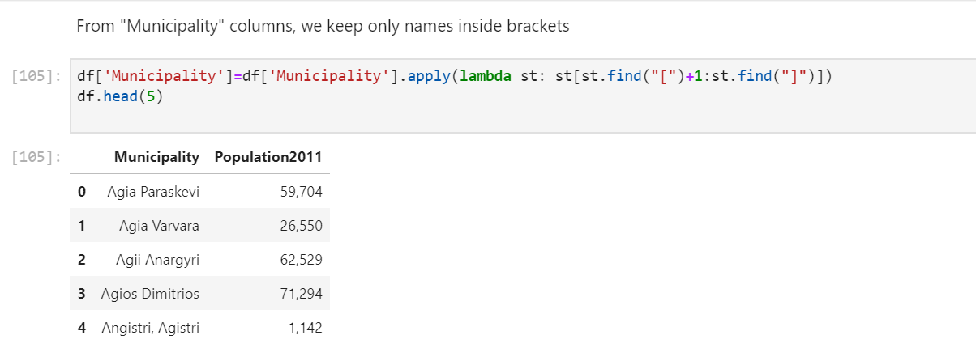

**Then, we read csv file to dataframe:**

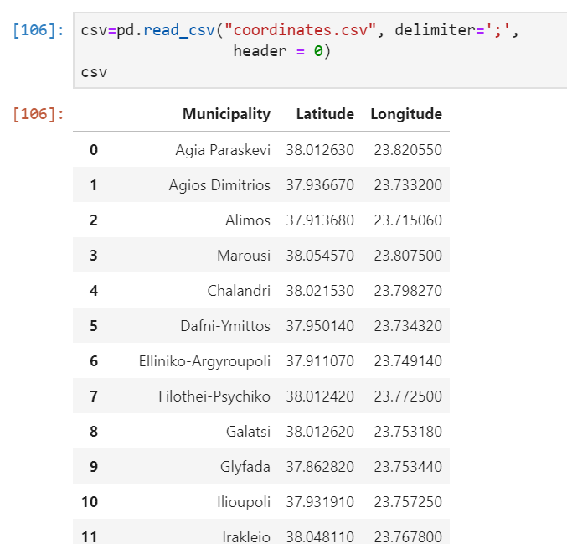

**To continue, I merge both dataframes and convert Population values to type float, so to be able to make calculation with these data:**

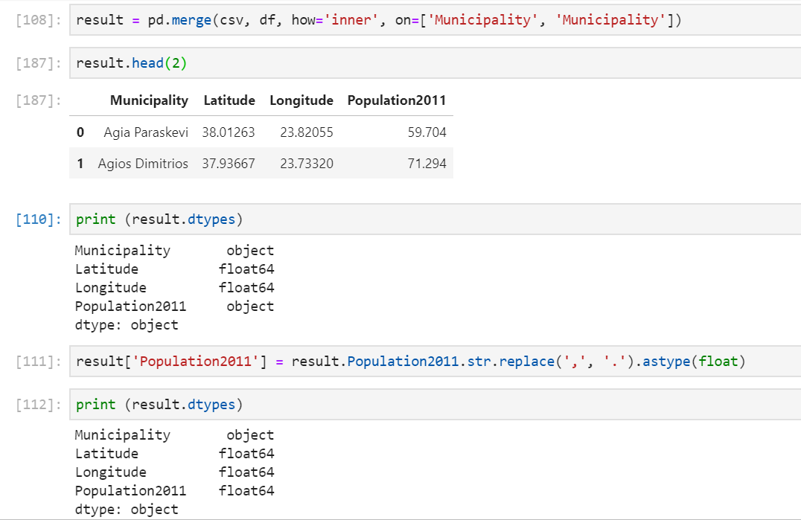

**Next, we fetch via Foursquare all Hospitals that are in these 65 Municipalities:**

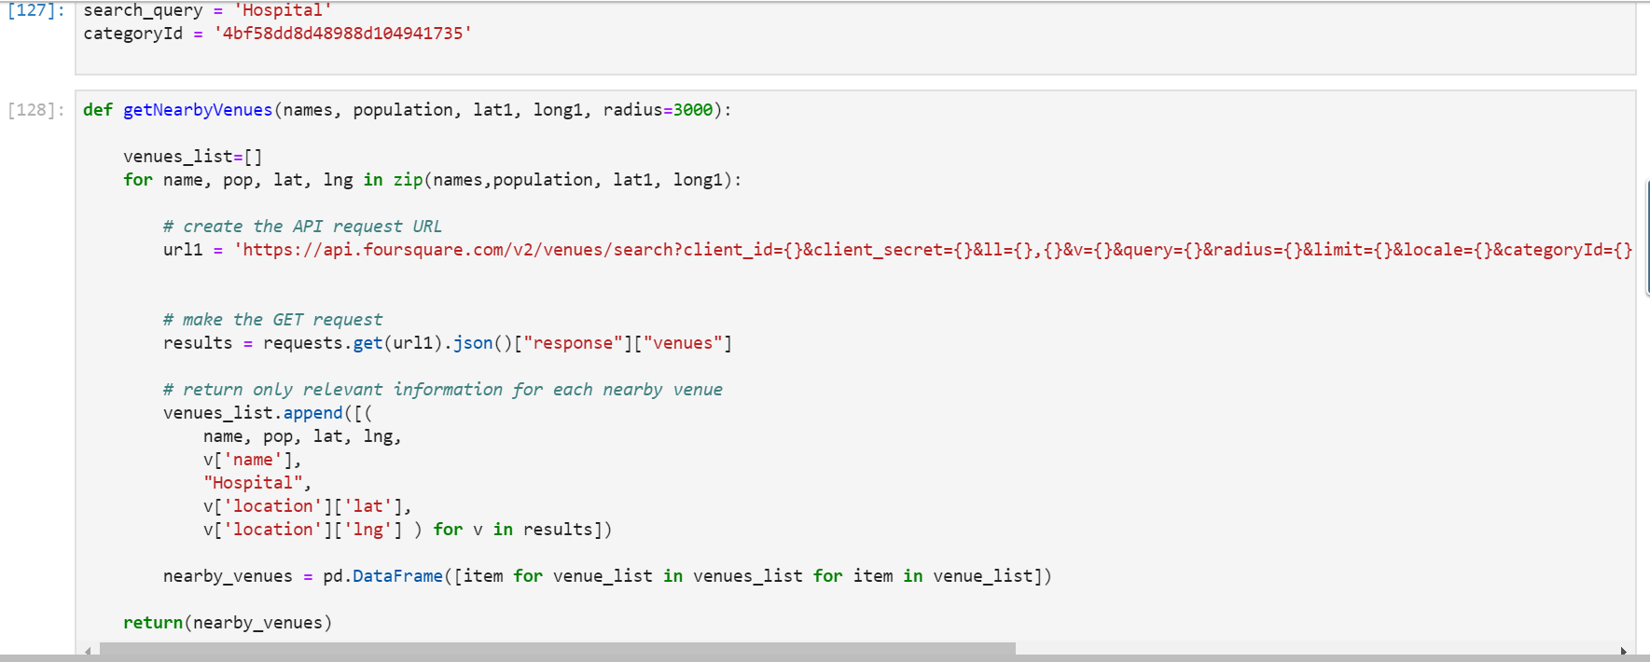

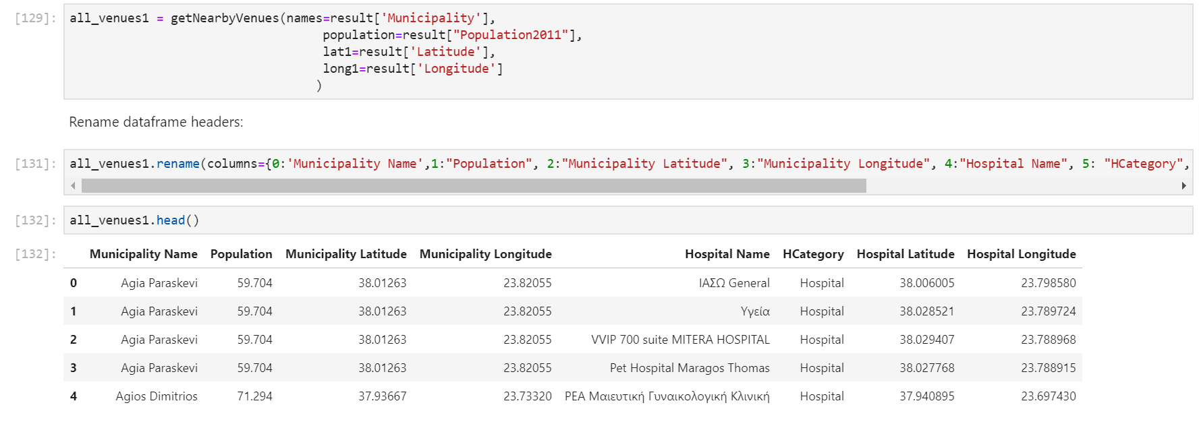

**So, we can see that dataframe “all_venues1” consists of 8 columns: Municipality name and its coordination, Municipality Population, and every Hospital that are belonging to this Municipality – Hospital name and its coordination. This dataframe contains of above for every Hospital for every 65 Municipalites.**

**To continue, I do the same process, to fetch all near Pharmacies for every Hospital that exist in my dataframe:**

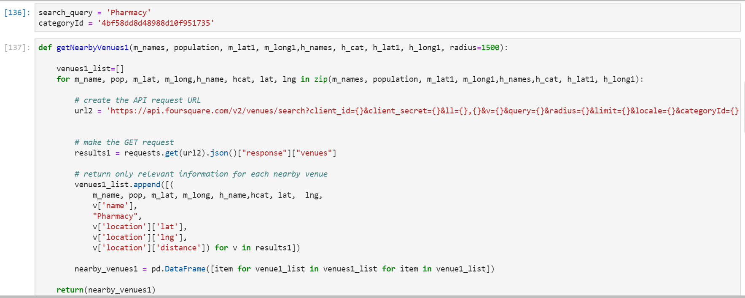

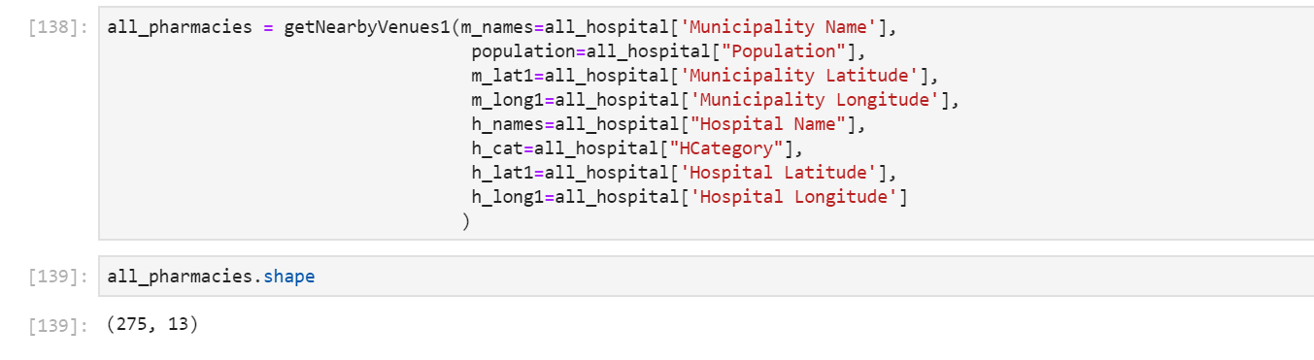

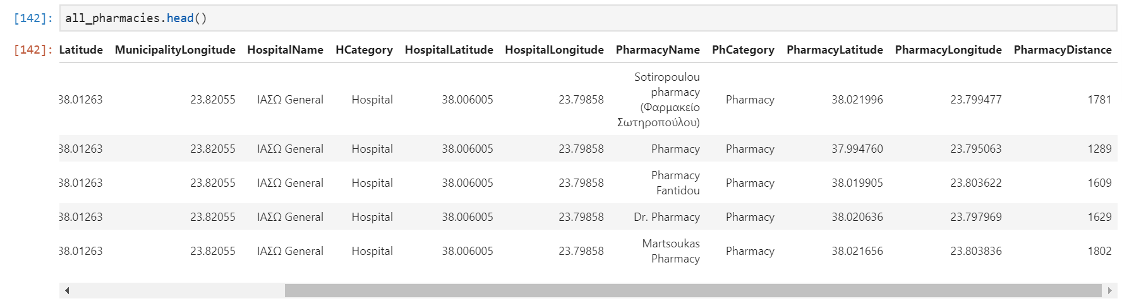

**As, we can see, last dataframe column is “PharmacyDistance” which is the distance between Hospital and Pharmacy, as second Foursquare query, I use Hospital coordinates to fetch each Pharmacy near to it.**

**Next, I need to calculate how many different Hospitals exist per Municipality and do the same for Pharmacies (e.g. to also calculate how many pharmacies exist near each Hospital):**

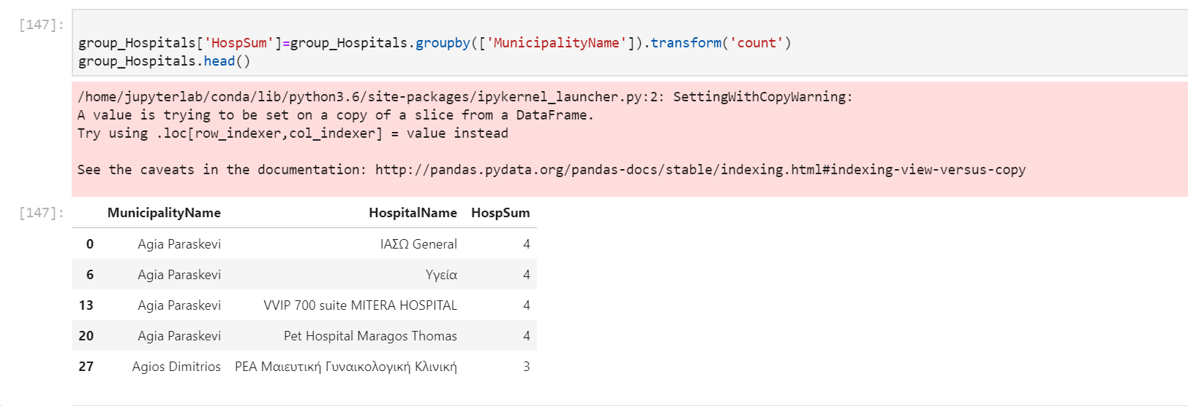

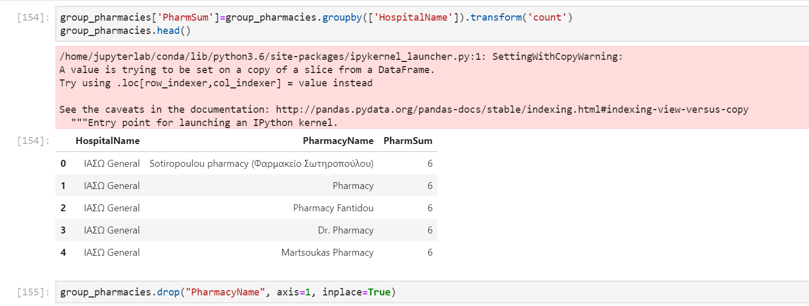

**New columns “HospSum” is the sum of Hospitals per Municipality, and new column “PharmSum” is the sum of Pharmacies per Hospital.**

**Then, I merge above two dataframes to original one, to have concatenate these two new columns:**

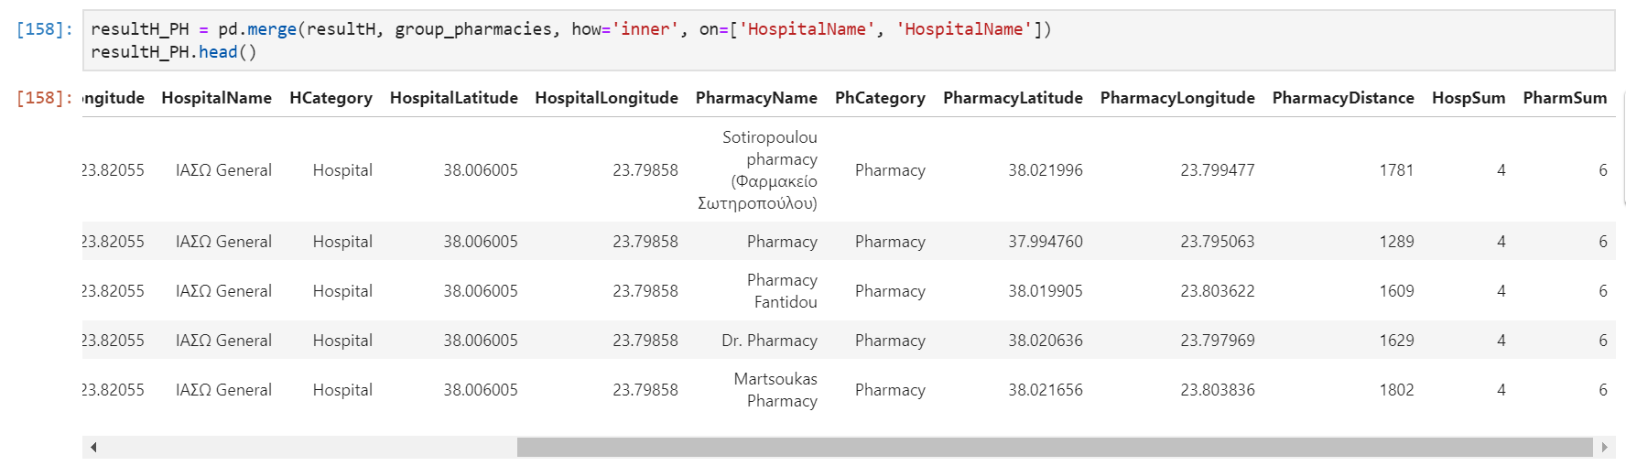

**According to original requirements, my friend Pharmacist wants to open its new Pharmacy store to a Municipality that have Hospital and also good Population Density.**

**So, “Density%” per Municipality is defined as: (“Population”*100%)/(HospSum*PharmSum)**

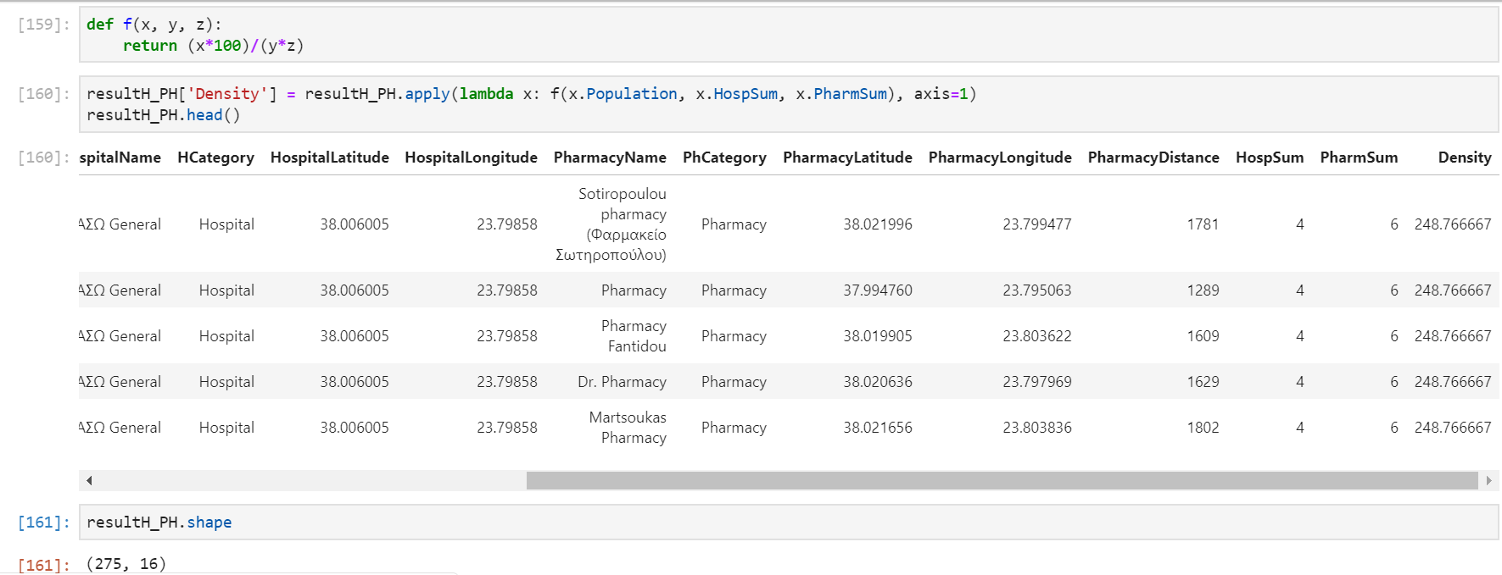

**Then, to clear the dataframe I drop some columns I do not need any more:**

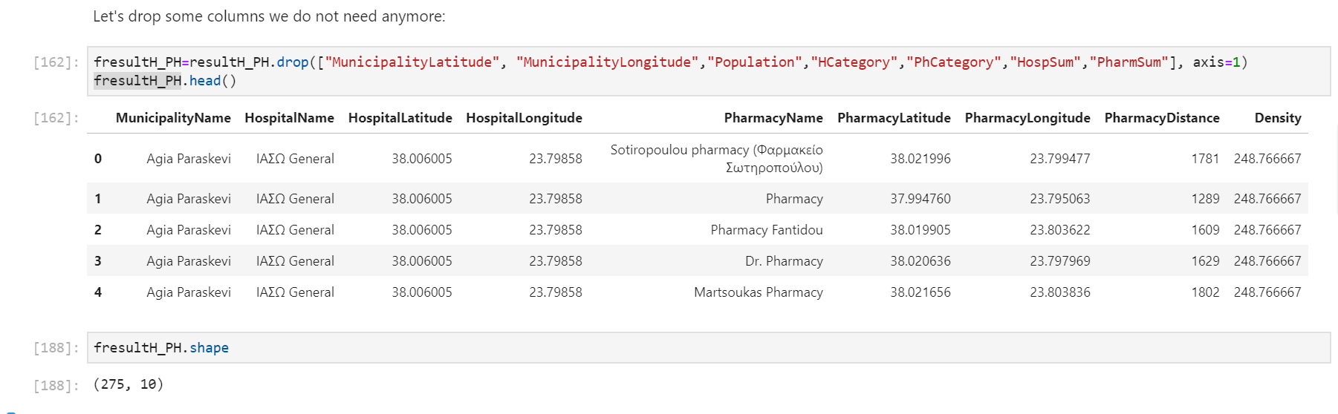

**Final dataframe “fresultH_PH” consists of 10 columns and 275 rows.**

**To be able to group Municipalities having similar Density value and Pharmacy distance and since my data are unsupervised, I use machine learning algorithm “k-means”:**

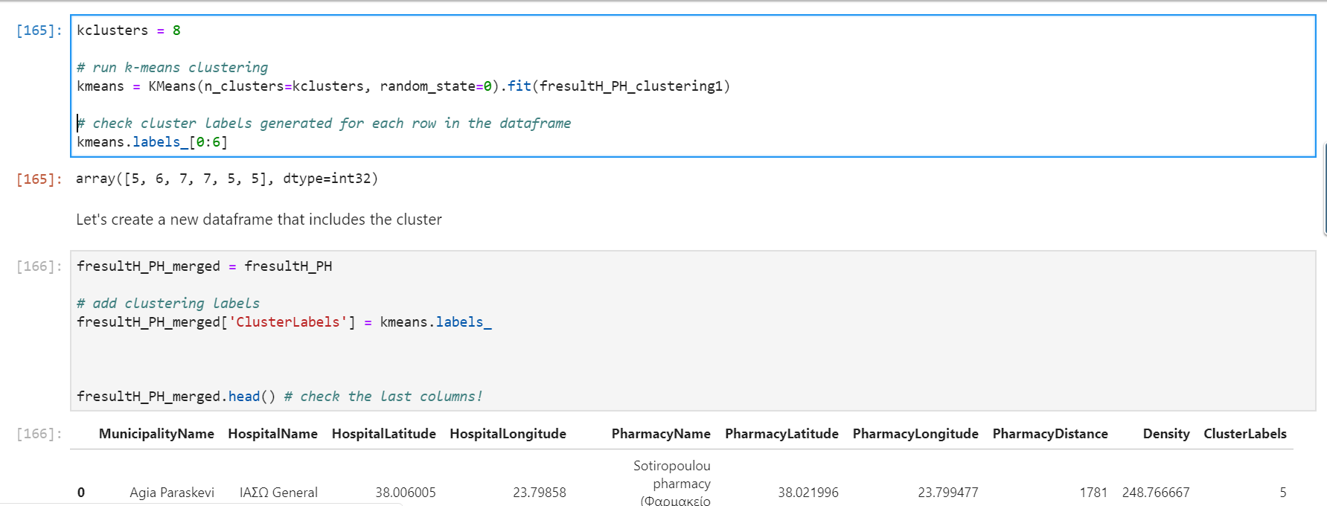

**Now, another one column is added “ClusterLabels” in final dataframe. Each row belongs to a cluster with label “ClusterLabels”.**

**To visualize how cluster is in Athens, Attica area, we can see below map:**

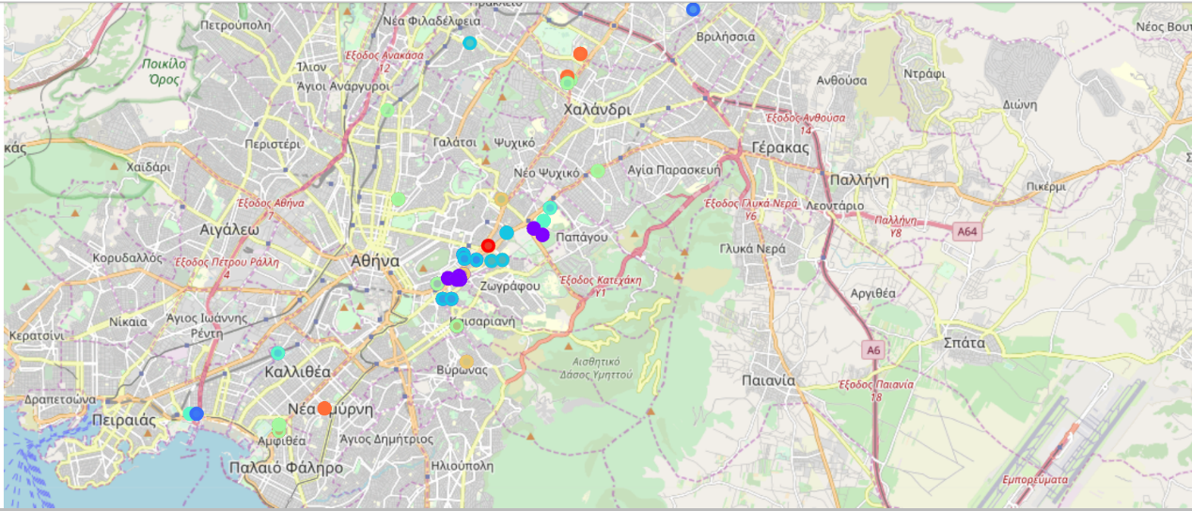

# **Results section**

To better understand Cluster grouping and to be able to propose the best location according to original requirements open new Pharmacy store, Cluster visualization applied:

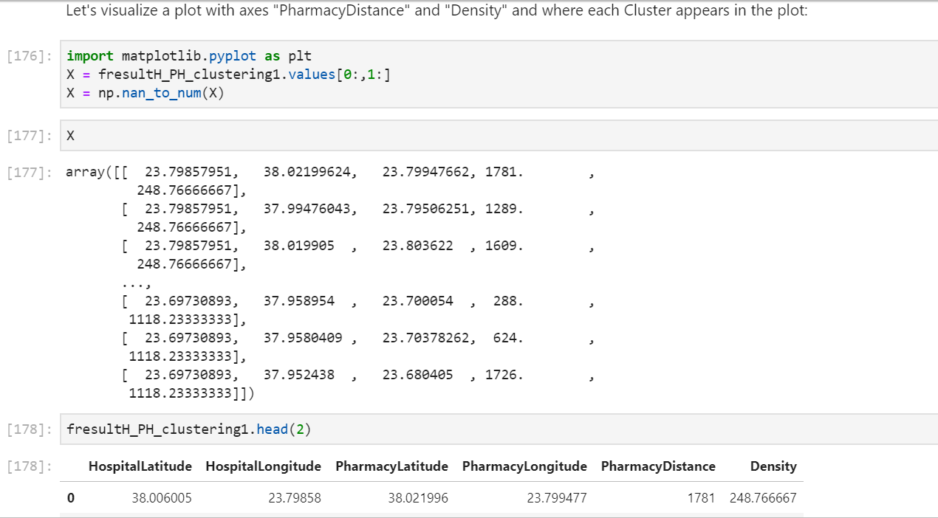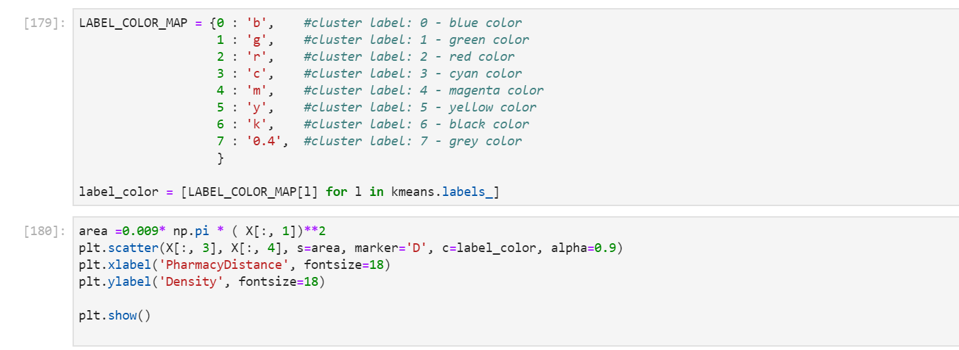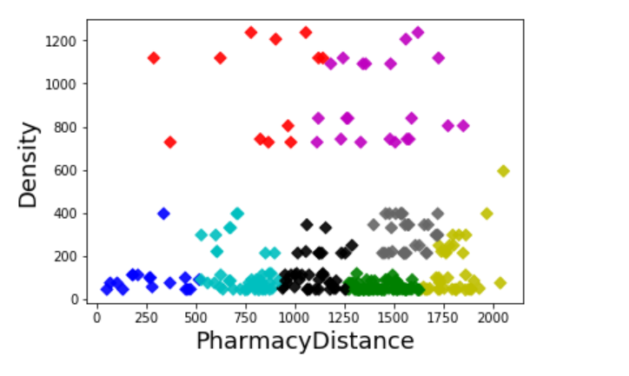

We can clearly see that clusters “cluster 4: Magenta” and “cluster 2: Red” contain Hospital having far other Pharmacies competitors and belonging to Municipalities with big Density.

We confirm above finding by sorting the final dataframe first by descending “Density” and then by ascending “PharmacyDistance”

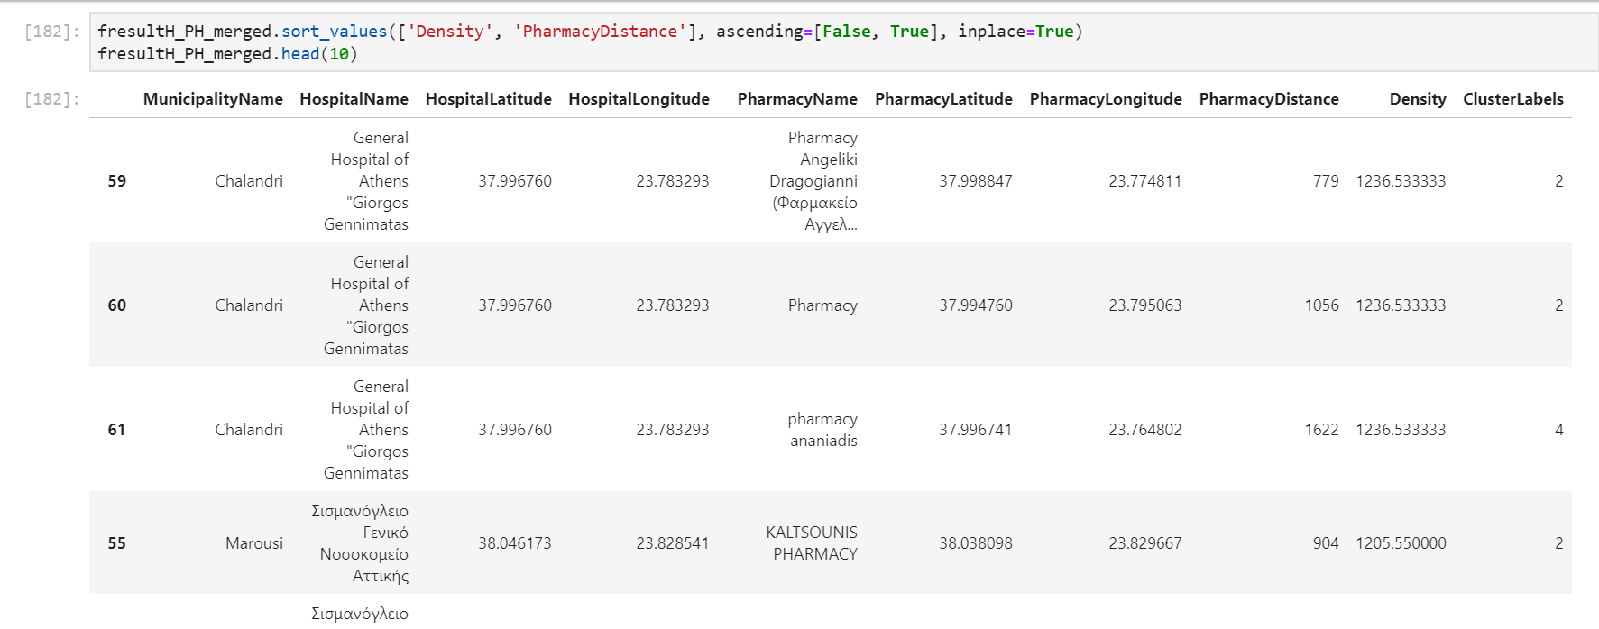

# **discussion section**

To able to propose more locations as alternatives, my friend Pharmacist can open his new Pharmacy Store near any hospital belonging in clusters 2 or 4:

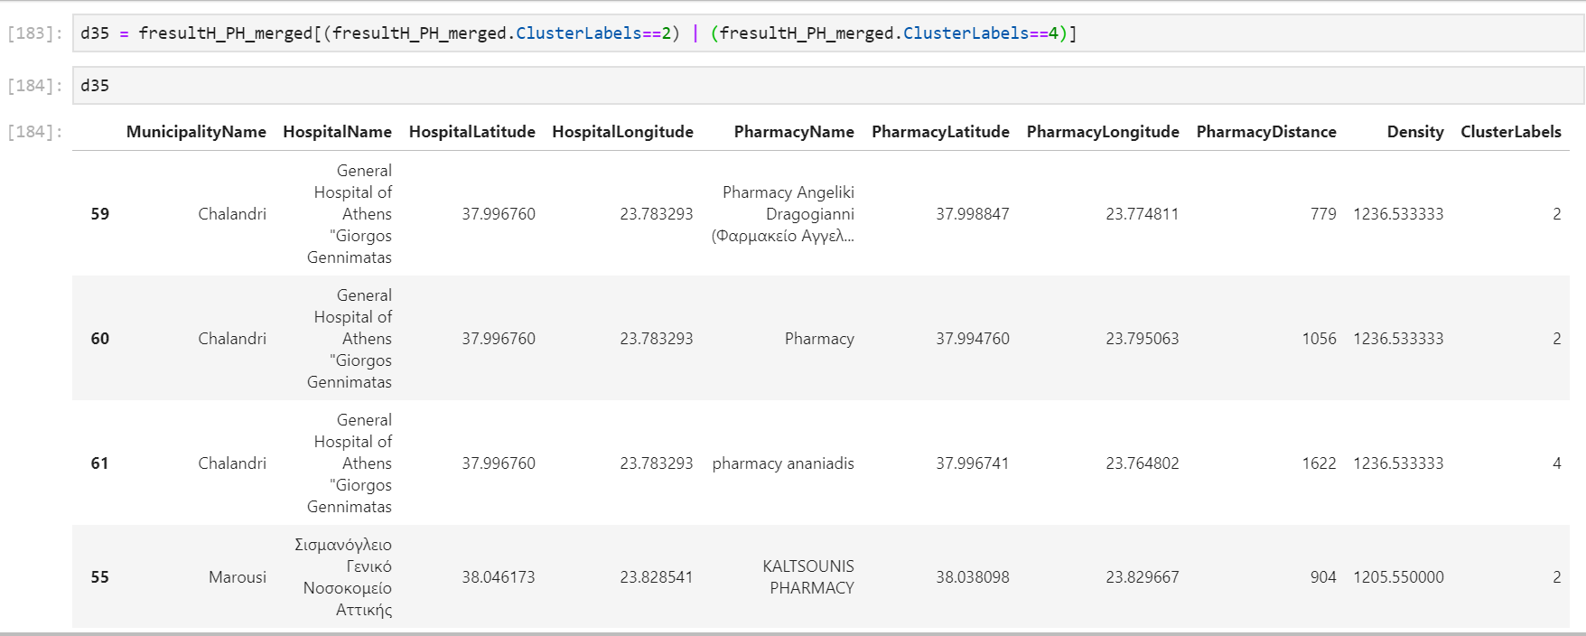

To visualize the Hospitals as Blue circles and competitor’s pharmacies are Red circles for Clusters 2 and 4, please check below map:

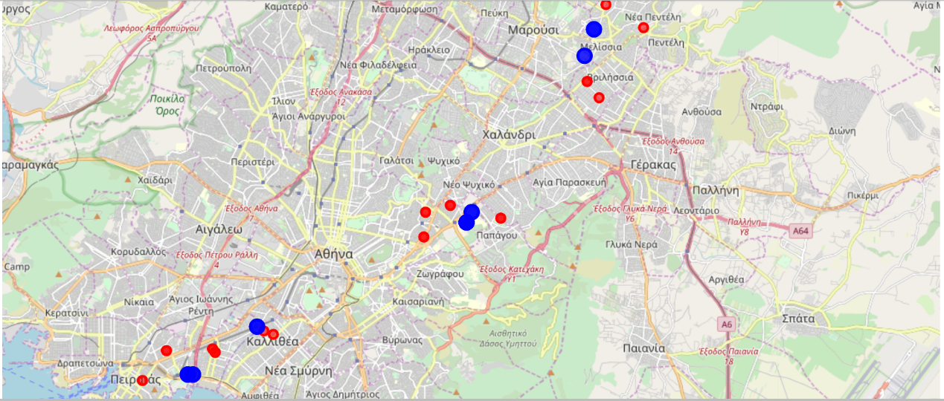

# **conclusion section**

My proposal to my friend Pharmacist to which location to open new Pharmacy store so to be near to Hospital but far away from other pharmacies competitors and in a Municipality with big Density population is to be:

In “Chalandri” Municipality, near hospital

“General Hospital of Athens "Giorgos Gennimatas”!

